Q2)

const { JSDOM } = require("jsdom");

const dom = new JSDOM(`

  <html>

    <body>

      <h1 id="title">Hello World!</h1>

    </body>

  </html>

`);

const document = dom.window.document;

console.log("Original Title:", document.getElementById("title").textContent);

document.getElementById("title").textContent = "Welcome to JSdom!";

console.log("Updated Title:", document.getElementById("title").textContent);

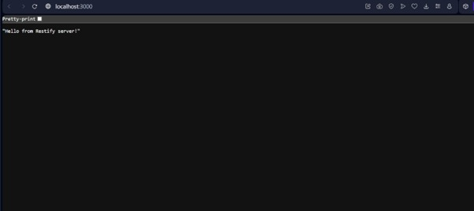

Q3) he **Code of Ethics** is a set of principles and standards that guide professional behavior in web development and technology.

**Why is it needed?**

* To promote honesty, fairness, and responsibility.
* To protect user privacy and data security.
* To ensure respect for intellectual property.
* To foster trust between developers, clients, and users.
* To encourage developers to build safe and inclusive web applications.

Q1) he **JSdom** package helps simulate a web browser's DOM environment inside Node.js.  
It is mainly used for:

* Testing JavaScript code that interacts with HTML.
* Web scraping and automation without needing a real browser.
* Server-side rendering of web content.
* Creating and modifying HTML elements in Node.js applications.